Check if the given Linked List is Palindrome

Algorithm / Intuition
The previous approach uses O(N) additional space, which can be avoided by reversing only half of the linked list and comparing the first and second halves. If they match, reverse the portion that was originally reversed, and then return true else return false.
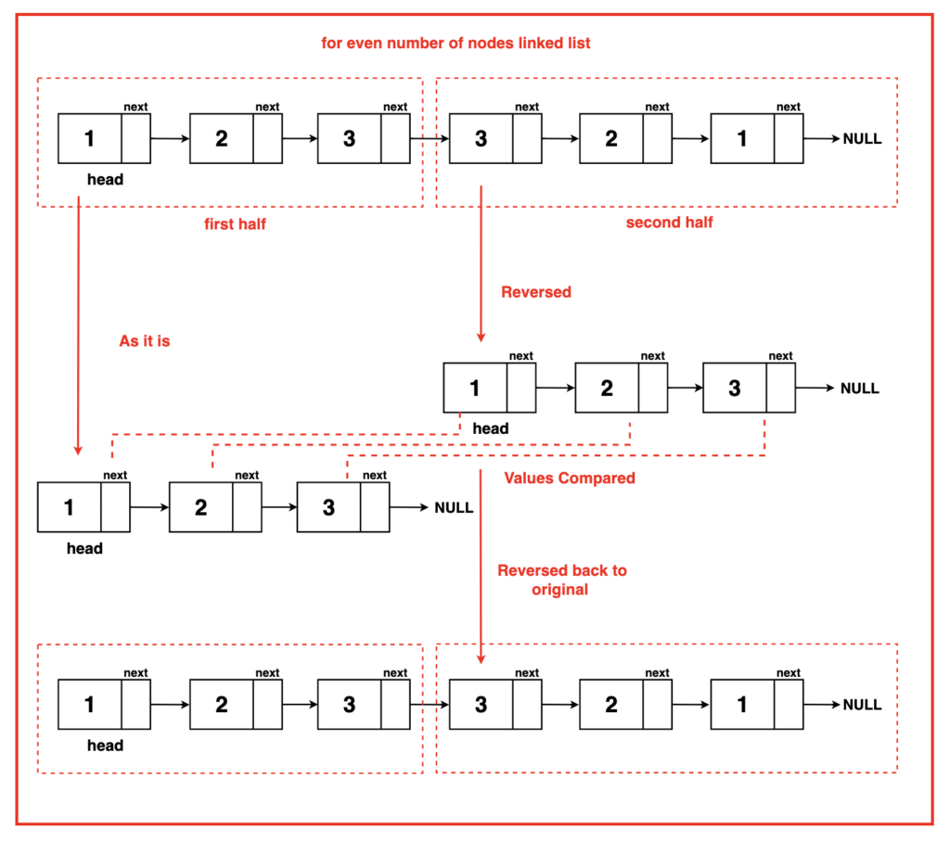
To implement this in-order reversal of the second half and its comparison with the first half has to be done in phases. The first step is dividing the first and second half of the linked list by recognizing the middle node using the Tortoise and Hare Algorithm. Read more about it here.
Algorithm:
Step 1: Check if the linked list is empty or has only one node. If that’s the case, it is a palindrome by definition, so return true.
Step 2: Initialise two pointers, ‘slow’ and ‘fast’, to find the middle of the linked list using the Tortoise and Hare Algorithm. The ‘slow’ pointer advances by one step at a time, while the ‘fast’ pointer advances by two steps at a time. Continue this until the ‘fast’ pointer reaches the end of the list or is the second last on the list. The ‘slow’ pointer will now be in the middle of the linked list.
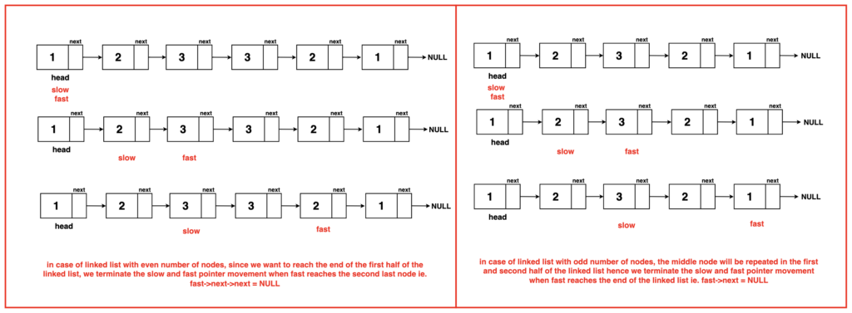
Step 3: Reverse the second half of the linked list starting from the middle (the ‘slow->next’ node). This is done by calling the reverse linked list function and returning the head of the new reversed linked list. Learn more about reversing the linked list.
Step 4: Create two pointers, ‘first’ and ‘second’, where ‘first’ points to the head of the linked list, and ‘second’ points to the new head of the reversed second half.
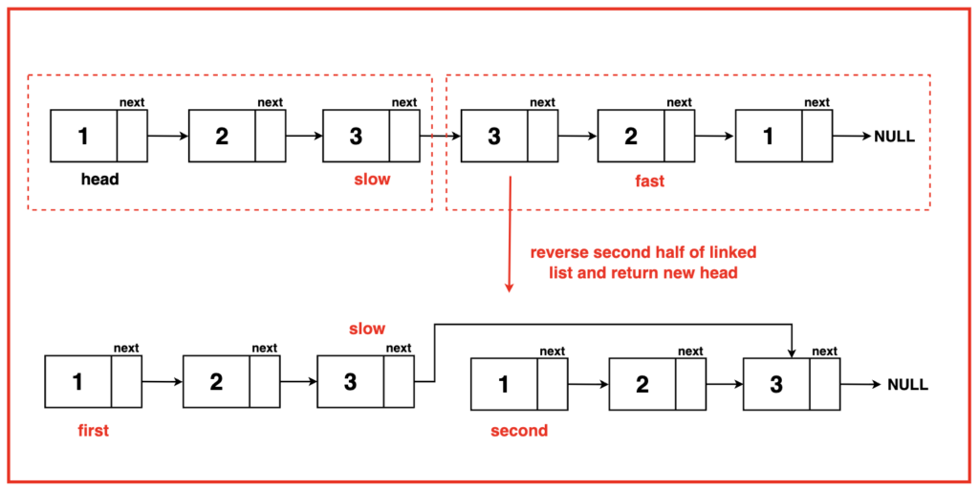
Step 5: Compare data values of nodes from both halves. If the values do not match, it means the list is not a palindrome. In this case, return ‘false’. Continue moving both ‘first’ and ‘second’ pointers through their respective halves, comparing the data values until one of them reaches the end of the list.
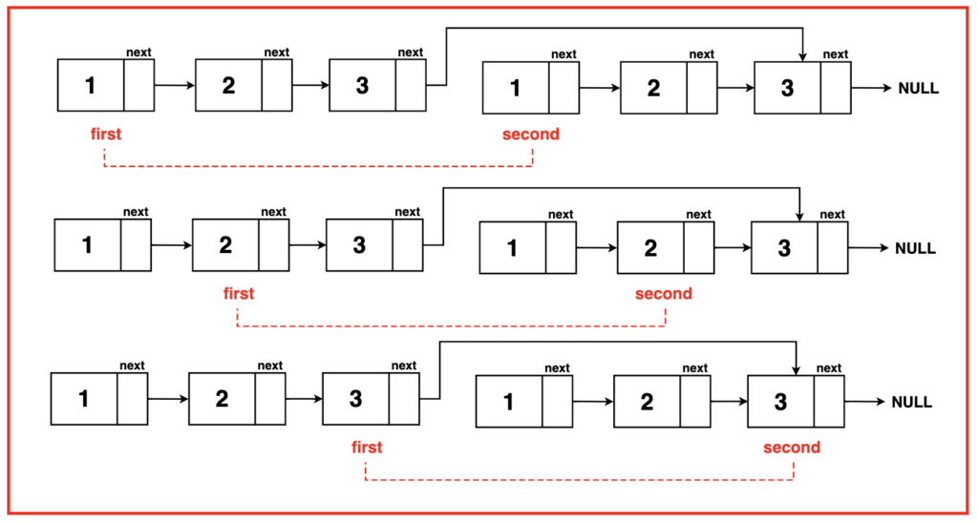
Step 6: After the comparison, reverse the second half back to its original state using the reverse linked list function and join back the linked list to its original state. Since all the values matched in the first half and reversed in the second half, return true. In case it does not match, return false.

import java.util.Stack;

// Node class represents a
// node in a linked list
class Node {
// Data stored in the node
int data;
// Pointer to the next
// node in the list
Node next;

// Constructor with both data
// and next node as parameters
Node(int data, Node next) {
this.data = data;
this.next = next;
}

// Constructor with only data as
// a parameter, sets next to null
Node(int data) {
this.data = data;
this.next = null;
}
}
// Function to reverse a linked list
// using the recursive approach
public Node reverseLinkedList(Node head) {
// Check if the list is empty or has only one node
if (head == null || head.next == null) {

// No change is needed;
// return the current head
return head;
}

// Recursive step: Reverse the remaining
// part of the list and get the new head
Node newHead = reverseLinkedList(head.next);

// Store the next node in 'front'
// to reverse the link
Node front = head.next;

// Update the 'next' pointer of 'front' to
// point to the current head, effectively
// reversing the link direction
front.next = head;

// Set the 'next' pointer of the
// current head to 'null' to
// break the original link
head.next = null;

// Return the new head obtained
// from the recursion
return newHead;
}

public static boolean isPalindrome(Node head) {
// Check if the linked list is
// empty or has only one node
if (head == null || head.next == null) {
// It's a palindrome by definition
return true;
}

// Initialize two pointers, slow and fast,
// to find the middle of the linked list
Node slow = head;
Node fast = head;

// Traverse the linked list to find the
// middle using slow and fast pointers
while (fast.next != null && fast.next.next != null) {
// Move slow pointer one step at a time
slow = slow.next;

// Move fast pointer two steps at a time
fast = fast.next.next;
}

// Reverse the second half of the
// linked list starting from the middle
Node newHead = reverseLinkedList(slow.next);

// Pointer to the first half
Node first = head;

// Pointer to the reversed second half
Node second = newHead;
while (second != null) {
// Compare data values of
// nodes from both halves

// If values do not match, the
// list is not a palindrome
if (first.data != second.data) {

// Reverse the second half back
// to its original state
reverseLinkedList(newHead);

// Not a palindrome
return false;
}

// Move the first pointer
first = first.next;

// Move the second pointer
second = second.next;
}

// Reverse the second half back
// to its original state
reverseLinkedList(newHead);

// The linked list is a palindrome
return true;
}

// Function to print the linked list
public static void printLinkedList(Node head) {
Node temp = head;
while (temp != null) {
System.out.print(temp.data + " ");
temp = temp.next;
}
System.out.println();
}

public static void main(String[] args) {
// Create a linked list with
// values 1, 5, 2, 5, and 1 (15251, a palindrome)
Node head = new Node(1);
head.next = new Node(5);
head.next.next = new Node(2);
head.next.next.next = new Node(5);
head.next.next.next.next = new Node(1);

// Print the original linked list
System.out.print("Original Linked List: ");
printLinkedList(head);

// Check if the linked list is a palindrome
if (isPalindrome(head)) {
System.out.println("The linked list is a palindrome.");
} else {
System.out.println("The linked list is not a palindrome.");
}
}

}
Complexity Analysis
Time Complexity: O (2* N) The algorithm traverses the linked list twice, dividing it into halves. During the first traversal, it reverses one-half of the list, and during the second traversal, it compares the elements of both halves. As each traversal covers N/2 elements, the time complexity is calculated as O(N/2 + N/2 + N/2 + N/2), which simplifies to O(2N), ultimately representing O(N).
Space Complexity: O(1) The approach uses a constant amount of additional space regardless of the size of the input linked list. It doesn't allocate any new data structures that depend on the input size, resulting in a space complexity of O(1).

